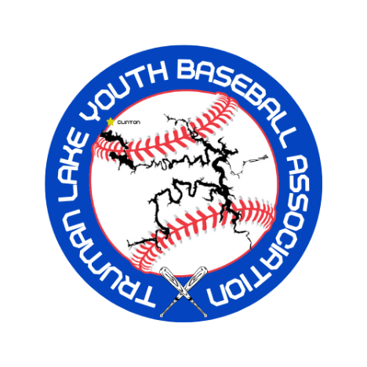

Truman Lake Youth Baseball Association

Player Registration Form
Minor League (10U)
Major League (14U)
Senior Major League (18U)
Player Information:
Player Name: ____________________________________ Birth Date: ____________________________________
Address: _________________________________________________________________ Age: _______________
City: ______________________________ State: ____________________________ Zip Code: ___________
Phone: _________________________________________ Email: ________________________________________
Pool Player? □ Yes □ No Shirt Size: __________ School Team (Middle or High School)? : _________________
Parent/Guardian Information:
Parent/Guardian #1: Parent/Guardian #2:
Name: _________________________________________ Name: ________________________________________
Phone: ________________________________________ Phone: _______________________________________
Email: _________________________________________ Email: ________________________________________
Medical Information:
Emergency contact: ______________________________ Relationship to Player: ___________________________
Phone: ________________________________________ Allergies: ______________________________________
Volunteer and Sponsorship Opportunities:
Truman Lake Baseball depends on Volunteers and Sponsors. If you would like to help, please fill in below:
Volunteer? □ Yes □ No Coach? □ Yes □ No Asst. Coach? □ Yes □ No
Name: _____________________ Name: _______________________ Name: _________________________
Concession Stand Fee: If you do not want to volunteer to work in the Concession Stand a $20 per player fee will be added.
Team Sponsor ($300) □ Yes □ No Sponsorship w/3’ x 5’ sign with your Logo ($300) □ Yes □ No
Name: _____________________________ Name: _____________________________________________________
Grand Slam Sponsorship ($500) □ Yes □ No Name: _______________________________________________
Registration Fees are $45 Per player. Please make checks payable to Truman Lake Youth Baseball Association.
Please find us on Facebook – Truman Lake Youth Baseball Association.
Any questions please email us at trumanlakeyouthbaseballassoc@gmail.com

RELEASE OF LIABILITY FOR MINOR PARTICIPANTS

READ BEFORE SIGNING - IN CONSIDERATION OF my child being allowed to participate in any way in the related events and activities, the undersigned acknowledges, appreciates, and agrees that:
The risks of injury and illness (ex: communicable diseases such as MRSA, influenza, and COVID-19) to my child from the activities involved in these programs are significant, including the potential for permanent disability and death, and while rules, equipment, and personal discipline may reduce these risks, the risks of serious injury and illness do exist; and,
- FOR MYSELF, SPOUSE, AND CHILD, I KNOWINGLY AND FREELY ASSUME ALL SUCH RISKS, both known and unknown, EVEN IF ARISING FROM THE NEGLIGENCE OF THE RELEASES or others, and assume full responsibility for my child’s participation; and,
- I willingly agree to comply with the program’s stated and customary terms and conditions for participation. If I observe any unusual significant concern in my child’s readiness for participation and/or in the program itself, I will remove my child from the participation and bring such attention of the nearest official immediately; and,
- I myself, my spouse, my child, and on behalf of my/our heirs, assigns, personal representatives and next of kin, HEREBY RELEASE AND HOLD HARMLESS Truman Lake Baseball; its directors, officers, officials, agents, employees, volunteers, other participants, sponsoring agencies, sponsors, advertisers, and if applicable, owners and lessors of premises used to conduct the event (“Releasees”), WITH RESPECT TO ANY AND ALL INJURY, ILLNESS, DISABILITY, DEATH, or loss or damage to person or property incident to my child’s involvement or participation in these programs, WHETHER ARISING FROM THE NEGLIGENCE OF THE RELEASEES OR OTHERWISE, to the fullest extent permitted by law.
- I, for myself, my spouse, my child, and on behalf of my/our heirs, assigns, personal representatives and next of kin, HEREBY INDEMNIFY AND HOLD HARMLESS all the above Releasees from any and all liabilities incident to my involvement or participation in these programs, EVEN IF ARISING FROM THEIR NEGLIGENCE to the fullest extent permitted by law.
- I, the parent/guardian, assert that I have explained to my child/ward: the risks of the activity, his/her responsibilities for adhering to the rules and regulations, and that my child/ward understands this agreement.

I, FOR MYSELF, MY SPOUSE, AND CHILD/WARD, HAVE READ THIS RELEASE OF LIABILITY AND ASSUMPTION OF RISK AGREEMENT, FULLY UNDERSTAND ITS TERMS, UNDERSTAND THAT WE HAVE GIVEN UP SUBSTANTIAL RIGHTS BY SIGNING IT, AND SIGN IT FREELY AND VOLUNTARILY WITHOUT ANY INDUCEMENT.
Name of Child: _____________________________________________
Name of Parent/Guardian: ___________________________________
Parent/Guardian Signature: __________________________________
Date Signed: ______________________________________________

UNDERSTANDING OR RISK
I understand the seriousness of the risks involved in participating in this program, my personal responsibilities for adhering to rules and regulations, and accept them as a participant.
Name of Child: ____________________________________________
Signature of Child/Ward: ____________________________________
Date Signed: ______________________________________________

